Wood carving workshop
Thank you for your interest in this workshop at Wilderness Wood. I’d just like to take this opportunity to tell you a bit about our tutor for the day.
Martin Brockman has been teaching woodland sculpture across Britain for many years. His roots are in the orchards of Kent where his family had worked the land for generations. Martin kept his link with the land by working with clay, he studied ceramics at Farnham, the heart of William Cobbett country.
After college, Martin toured extensively with Welfare State International – world-famous site-specific theatre group. He has worked in many different materials; ceramics, fire, wood and different forms of printing.
More recently, Martin has been designing and building structures for large public events such as ‘Glow Wild’ at Wakehurst Place, he also regularly exhibits at the Black Shed Gallery in Robertsbridge.
This one-day course is suitable for beginners, as well as those who are familiar with the techniques and just want to play for a day.
Whether you’ve never handled a chisel before or have some basic knowledge of wood carving, this workshop, will help you build your skills.
Martin will introduce you to a variety of wood carving techniques and help you assess working in three dimensions – either in the round, starting with a log, or bas-relief, working on a plank of wood. There will be a selection of locally sourced logs and planked lime from the local sawmill.
As time is limited, Martin suggests that you keep it as simple as possible – something like a bird or leaf seems to work well, this can be your starting point to create a unique sculpture from the woods.

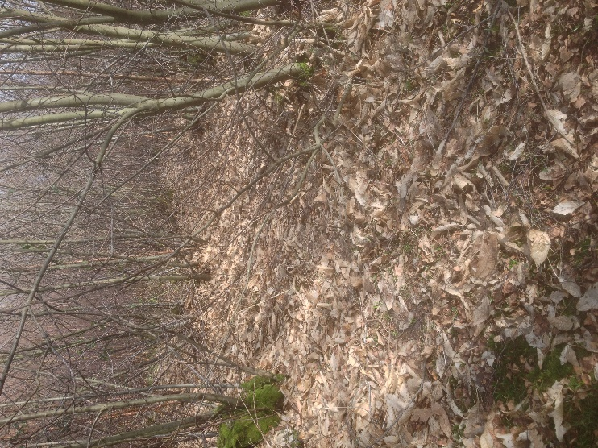
The venue for the workshop is Wilderness Wood in Hadlow Down.
Wilderness Wood is a successful forestry enterprise, which includes Schools without Walls, Andy Coates’ Woodland Products and The Hatch (for light refreshments). It’s a popular place to visit for schools and families.

Wilderness Wood, Hadlow Down, East Sussex, TN22 4HJ
www.wildernesswood.org
There is ample parking, on arrival please meet at the Hatch.
N. B. 10% discount for members of Wilderness Wood
If you need to contact me: adele@blackbirdarts.co.uk
07969 119479 Thanks, Adele

